

**Faculty of engineering - Shoubra**

**Benha University**

# Literature Review

in fulfillment of the requirements of

|  |  |
| --- | --- |
| **Department** | **Engineering Mathematics and Physics** |
| **Division** | **--------------** |
| **Academic Year** | **2019-2020 Preparatory** |
| **Course name** | **Computer** |
| **Course code** | **ECE006** |

## Title: -

**Artificial intellegence**

By:

|  |  |  |  |
| --- | --- | --- | --- |
|  | Name | Edu mail | B.N |
| 1 | احمد بهجت عبد اللطيف محمد | ahmed195037@feng.bu.edu.eg | 36 |

**Approved by:**

|  |  |
| --- | --- |
| Examiners committee | Signature |
| Dr.Ahmed Bayoumi |  |
| Dr.Shady Elmashad |  |
| Dr. Abdelhamid Attaby |  |

**Name:** احمد بهجت عبد اللطيف محمد

**B.N:** 36

**Email:** ahmed195037@feng.bu.edu.eg

**Topic:** artificial intelligence

**GitHub page:**

**GitHub link of application:**

# Research objectives

• Make website by HTML language.

• Discuss the artificial intelligence.

• Upload your website source code into my GitHub account.

• Make 4 pages related to main page.

# Application brief

From SIRI to self-driving cars, artificial intelligence (AI) is progressing rapidly. While science fiction often portrays AI as robots with human-like characteristics, AI can encompass anything from Google’s search algorithms to IBM’s Watson to autonomous weapons.

Artificial intelligence today is properly known as narrow AI (or weak AI), in that it is designed to perform a narrow task (e.g. only facial recognition or only internet searches or only driving a car). However, the long-term goal of many researchers is to create general AI (AGI or strong AI). While narrow AI may outperform humans at whatever its specific task is, like playing chess or solving equations, AGI would outperform humans at nearly every cognitive task.

**Screenshots for pages**

**Main page**

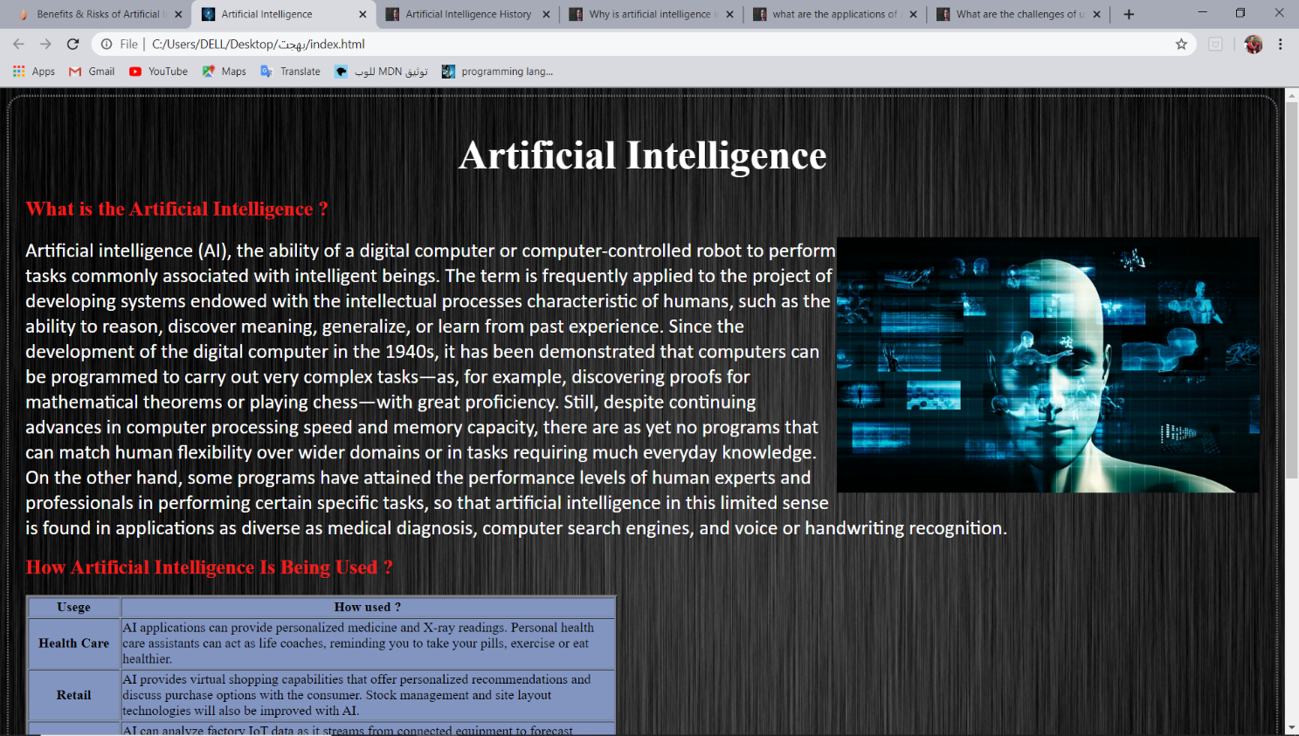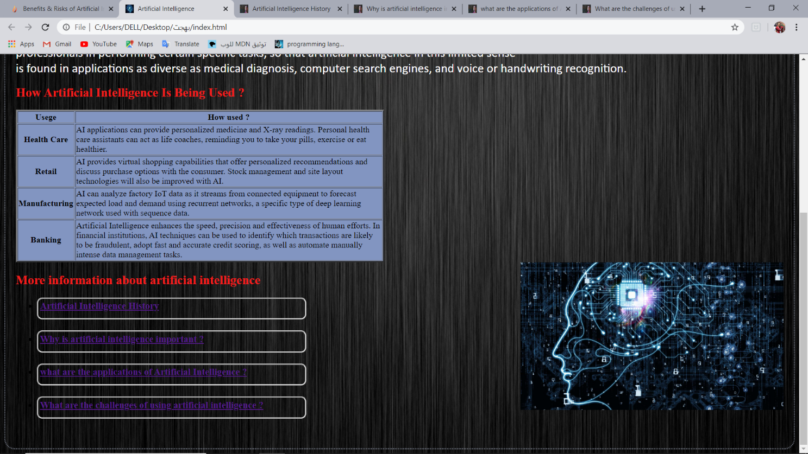

**The related pages**

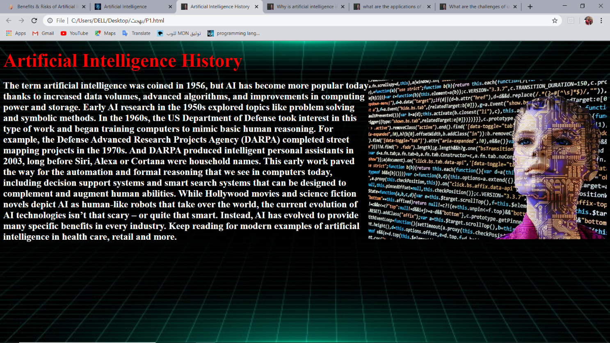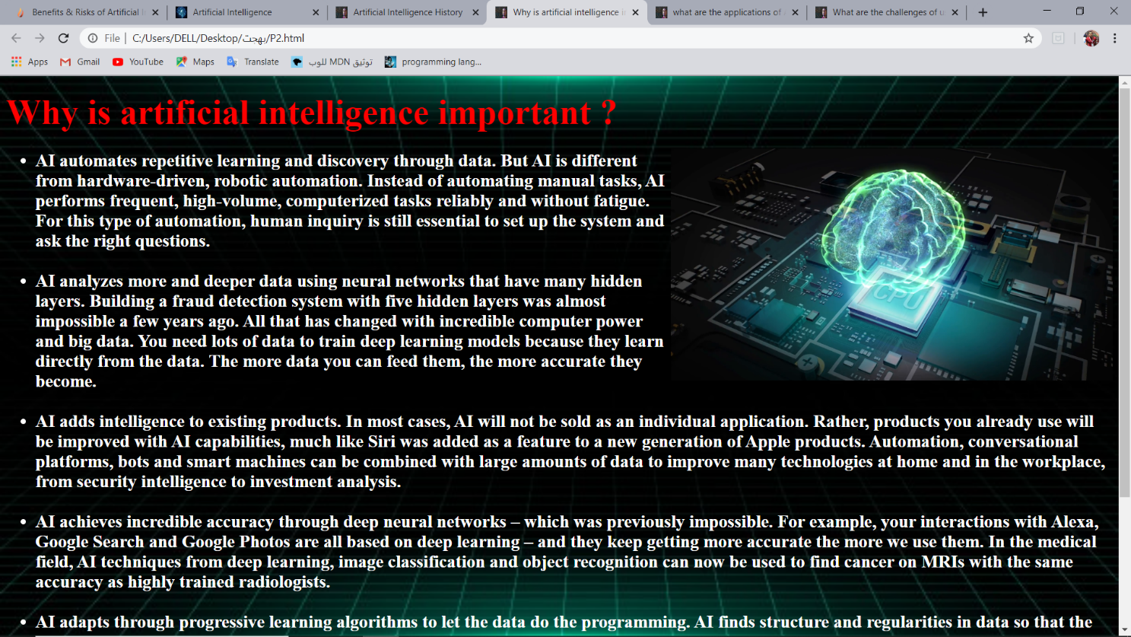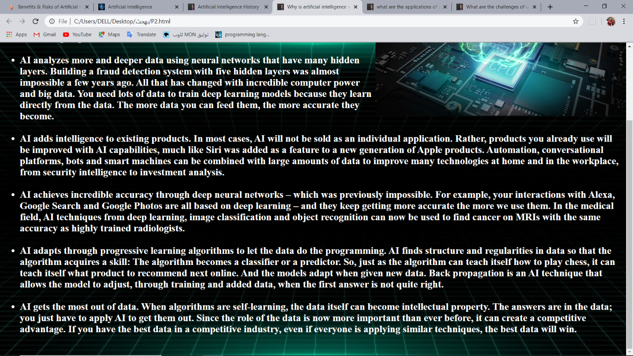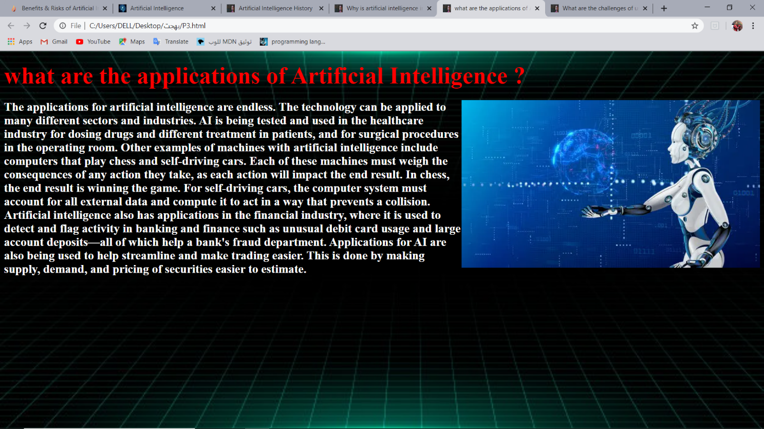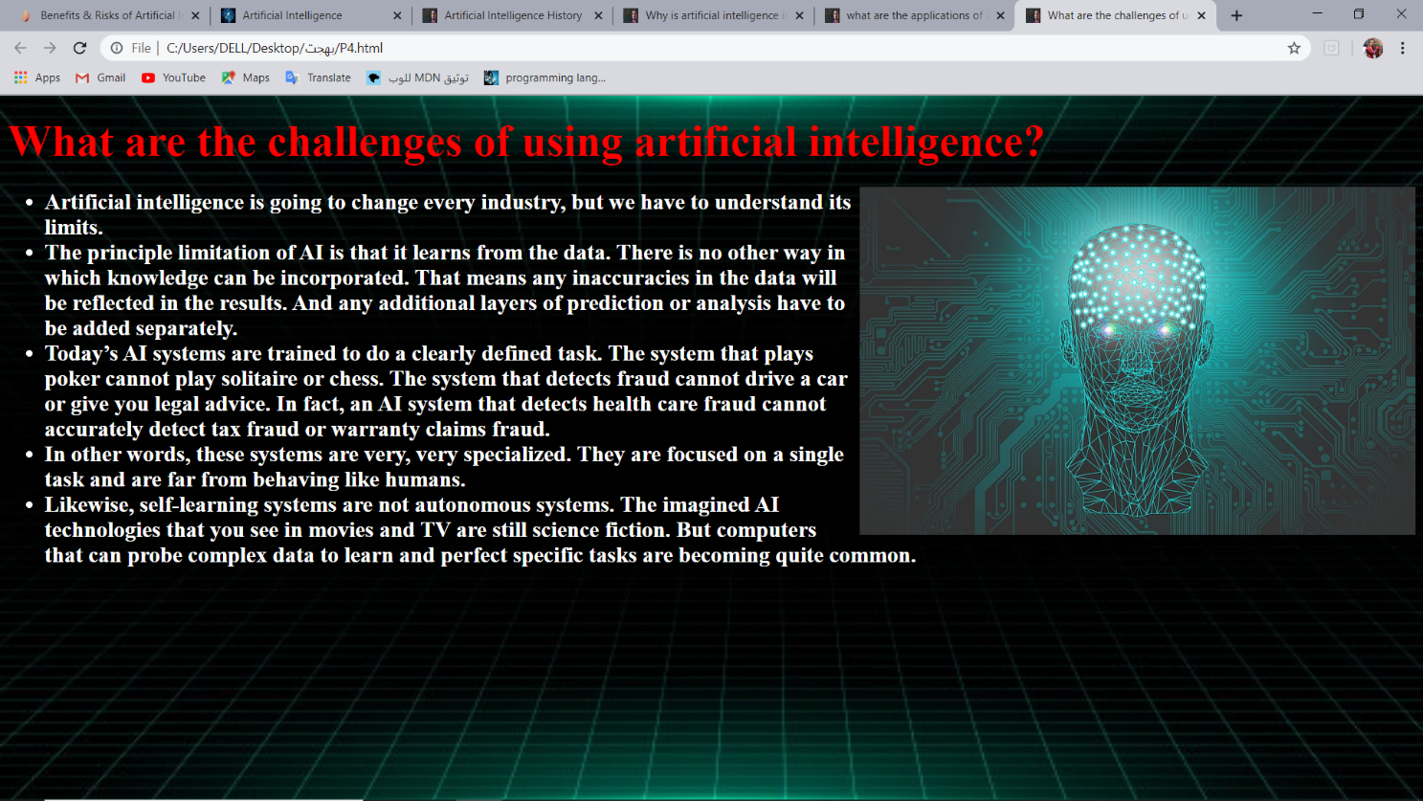

**Screenshots for Code**

**Code of main page**



**Code of related pages:**



